ST0501 FRONT-END WEB DEVELOPMENT
INDIVIDUAL CA2 REFLECTION JOURNAL

Student Name:Hajrah Azmiyyah Binti Abdul Azees Admin Number: P2618791
Class:DCITP/FT/1A/04 Group No:4

Objective :
This Reflection Journal requires you to critically analyze your CA2 project decisions, technical issues, and your responsible use of AI tools. Tutors are looking for depth of thought and examples that demonstrate understanding of your work.
Instructions:
- Answer all 3 parts below
- Total word count : 900-1200 words
- Use examples from your CA2 or class activities where relevant
- Submitted individually via BrightSpace.
- Attach your AI prompt logs using the Academic Integrity Declaration link (available in BrightSpace) in Appendix, this will not be included in the wordcount.

Part 1: Reflection on Styling Frameworks & Interactivity
- What changes are made to the original plan? Why are the changes necessary? And what impact do they cause e.g on the website, user experience, performance etc?
- Analyze the trade-offs between using a front-end styling framework (e.g., Bootstrap/Tailwind) and writing custom CSS in your project. How did your choice affect the efficiency, design flexibility, or maintainability of your website?
- Evaluate one interactive feature (e.g., form validation, DOM update, dynamic menu) you implemented: How well does it improve user experience? If you had to enhance it further, what changes would you make and why?

Word Count Suggestion: 250-450 words. (Write your answer here)

There were several changes made to our original plan. One change was adding flip cards to some of our pages. The flip cards were not part of our original design, but we added them to make the website more interactive and to present information more interestingly. Another change was made to our navigation bar. Originally, all the navigation options were displayed in one line. This made the navigation bar look crowded and messy, especially because our website had 12 pages. We changed it so that related pages were placed into categories that users can expand and collapse. This made the navigation bar more organised and easier to use.

We chose Bootstrap as our styling framework because it helped us build responsive pages quickly using ready-made components and grid layouts. This improved development efficiency and made the website easier to maintain. However, Bootstrap limited some design flexibility, so we used custom CSS to personalise colours and spacing. Combining Bootstrap with custom CSS allowed us to create a good-looking website.

One interactive feature I implemented was the flip card. It improves the user experience by allowing users to interact with the content and reveal additional information without making the page too wordy.

sPart 2: Reflection on JavaScript & DOM Interactivity
- What changes are made to the original plan? Why are the changes necessary? And what impact do they cause e.g on the website, user experience, performance etc?
- Which JavaScript feature you added (e.g., image gallery, menu toggle, validation) made the biggest impact on your website’s user experience? Why?
- Think about the form your created in CA2 or practiced in class: What makes a form easy or hard for users to complete? What is one improvement you would suggest making a form more user-friendly, and why?

Word Count Suggestion: 250-450 words. (Write your answer here)

Originally, there were no flip cards in my website design. However, after completing the page, I noticed that the layout looked too plain and was not interactive. Therefore, I added flip cards to make the content more engaging and visually appealing.

The JavaScript feature that made the biggest impact on my website’s user experience was the Daily Cardio Challenge with an interactive timer. This feature allows users to complete a different fitness challenge each day, such as completing 3 rounds of 1-minute jump rope exercises. The timer makes the website more interactive because users can track their workout duration instead of only reading fitness information.

A form is easy to complete when it has clear labels, simple instructions, and only asks for necessary information. A form becomes difficult when it contains too many fields, unclear instructions, or confusing layouts. One improvement I would suggest is adding clear error messages when users enter invalid information or leave some boxes empty. This would help users understand what they need to correct instead of having to guess what went wrong.

Part 3: Reflection on AI Usage and Evidence of Understanding

- Analyze your use of AI during this project: Which specific problem or task did AI help you with, and why did you choose to use AI for it?
- Choose one example where you used AI to help with coding for your website. Show the original AI-generated snippet and your modified version. Explain what you changed and why. How did your changes make the code better or fit your project needs?

Word Count Suggestion: 250-450 words. (Write your answer here)

During this project, I used AI mainly to help me solve coding problems. It helped me with HTML, CSS, and JavaScript, especially when creating interactive features such as flip cards. I chose to use AI when I was unsure why the code was not working because it could help me identify errors in my code and explain what I needed to change.

One example where I used AI was when my flip cards suddenly stopped working after I modified my website and uploaded the changes to GitHub. I used AI to check my HTML structure and find the problem. AI identified that some of my HTML elements were not properly closed. For example, my original code had a <button> and a <div class="col-md-3"> that were not closed properly. I also corrected the spelling of “Breakfas” to “Breakfast” and made sure the <div> elements were properly closed.

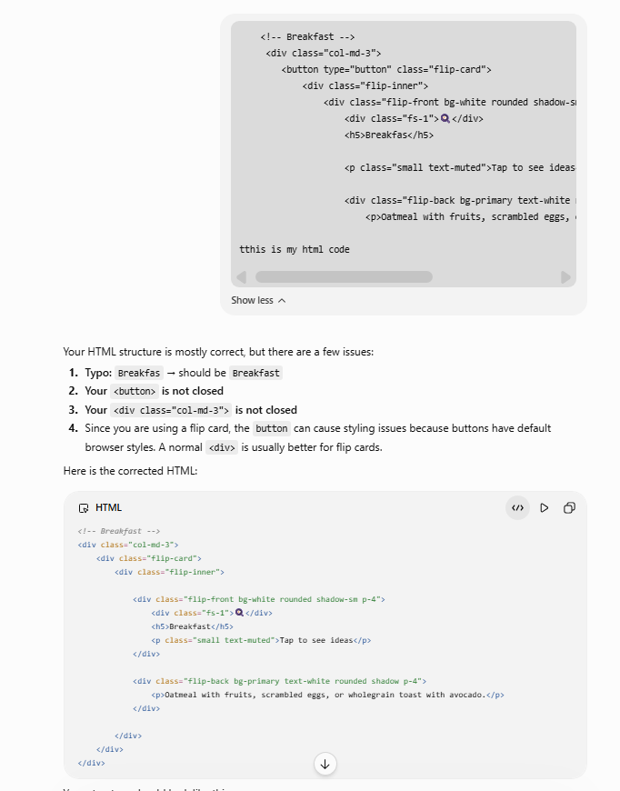

Appendix (e.g AI outputs or evidences you would like to include, this will not be included in the wordcount)

~~ The End ~~

